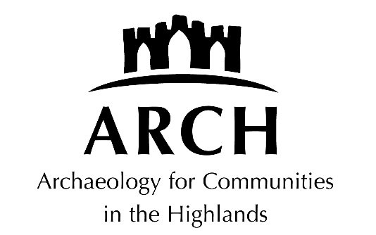

DISCIPLINARY PROCEDURE

Checked and approved: July 2021, 2024

The following definitions apply to this document:

1. Board members: members appointed to ARCH board;
2. Employees/staff: paid individuals who undertake work for ARCH on behalf of the company;
3. Volunteers: unpaid individuals who help run events on the company’s behalf; and
4. Members of the public: members of the public who attend ARCH events.

Purpose and scope

The organisation's aim is to encourage improvement in individual conduct or performance. This procedure sets out the action which will be taken when unsatisfactory performance or conduct is identified.

Principles

1) The procedure is designed to establish the facts quickly and to deal consistently with disciplinary issues. No disciplinary action will be taken until the matter has been fully investigated.
2) At every stage an employee will have the opportunity to state their case and be represented or accompanied, if s/he wishes, by a co-worker of their choice / trade union representative / legal representative or friend.
3) An employee has the right to appeal against any disciplinary penalty.

The Procedure

Stage 1 - first warning

If conduct or performance is unsatisfactory, the employee will be given a written warning or performance note. Such warnings will be recorded, but disregarded after 6 months of satisfactory service. The employee will also be informed that a final written warning may be considered if there is no sustained satisfactory improvement or change. (Where the first offence is sufficiently serious, for example because it is having, or is likely to have, a serious harmful effect on the organisation, it may be justifiable to move directly to a final written warning.)

Stage 2 - final written warning

If the offence is serious, or there is no improvement in standards, or if a further offence of a similar kind occurs, a final written warning will be given which will include the reason for the warning and a note that if no improvement results within an agreed period, action at Stage 3 will be taken.

Stage 3 - dismissal or action short of dismissal

If the conduct or performance has failed to improve, the employee may suffer demotion, disciplinary transfer, loss of seniority (as allowed in the contract) or dismissal.

Statutory discipline and dismissal procedure

If an employee faces dismissal - or action short of dismissal such as loss of pay or demotion - the minimum statutory procedure will be followed. This involves:

- step one: a written note to the employee setting out the allegation and the basis for it;
- step two: a meeting to consider and discuss the allegation;
- step three: a right of appeal including an appeal meeting.

The employee will be reminded of their right to be accompanied.

Gross misconduct

If, after investigation, it is confirmed that an employee has committed an offence of the following nature (the list is not exhaustive), the normal consequence will be dismissal without notice or payment in lieu of notice:

theft, damage to property, fraud, incapacity for work due to being under the influence of alcohol or illegal drugs, physical violence, bullying and gross insubordination.

While the alleged gross misconduct is being investigated, the employee may be suspended, during which time he or she will be paid their normal pay rate. Any decision to dismiss will be taken by the employer only after full investigation.

Appeals

An employee who wishes to appeal against any disciplinary decision must do so to the named person in the organisation within five working days. The employer will hear the appeal and decide the case as impartially as possible.

